8-QueenProblem
AIM:
To write a Python program to solve the 8-Queen Problem by placing eight queens on a chessboard without attacking each other.

ALGORITHMS:
8-Queen Problem
- Start.
- Place a queen in the first row.
- Check whether the position is safe.
- If safe, place the queen and move to the next row.
- If not safe, try another column.
- Repeat until all eight queens are placed.
- Display the solution.
- Stop.
CODE:

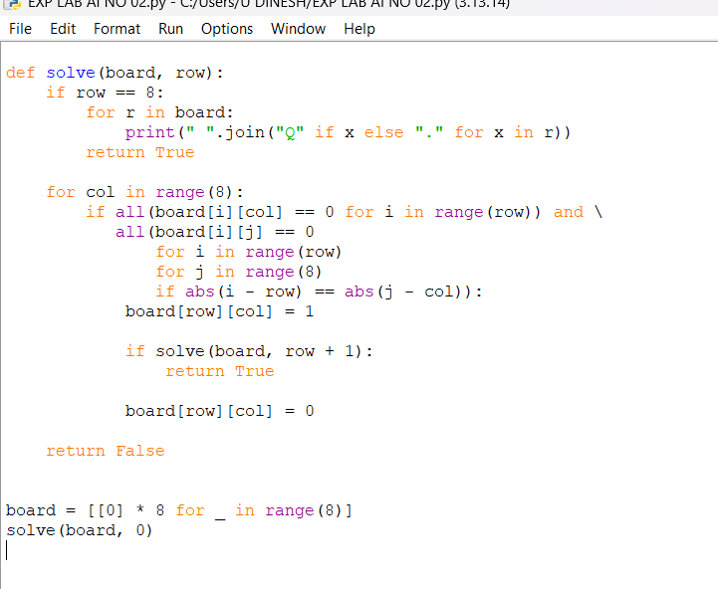

OUTPUT:
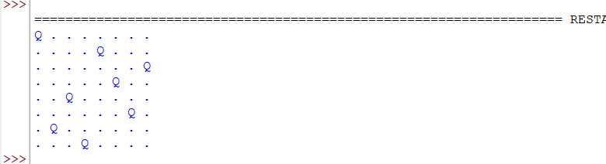

RESULT:
Eight queens are placed on the chessboard so that no two queens attack each other.

